NAME: S.PRATIBA REG NO: 241901080

Experiment 15: Detect SQL Injection Vulnerabilities Using Various SQL Injection Detection Tools

Aim :
To use automated tools to detect SQL Injection vulnerabilities before they can be exploited, as part of a security assessment.

Theory :
Detection tools work by sending a wide range of crafted inputs (single quotes, boolean conditions, time-delay payloads) to every parameter of an application and analyzing the response differences (error messages, timing delays, content changes) to confirm whether the parameter is vulnerable — without necessarily extracting real data.

Tools Required :
- sqlmap (detection mode)
- OWASP ZAP (Active Scan — SQLi rules)
- Target: DVWA (SQL Injection module, Low security)

Procedure :
Step 1 — Detection using sqlmap (no dumping, just confirm)
sqlmap -u "http://<target-ip>/dvwa/vulnerabilities/sqli/?id=1&Submit=Submit" --cookie="PHPSESSID=<session-id>; security=low" --batch --level=3 --risk=2
sqlmap reports which parameter is injectable and which injection technique works (boolean-based blind, time-based blind, UNION query, error-based, stacked queries).
Step 2 — Time-based blind detection concept sqlmap internally tests payloads like:
1 AND IF(1=1, SLEEP(5), 0)
If the response takes ~5 seconds longer, the parameter is confirmed vulnerable to blind SQLi — even with no visible error or data change.
Step 3 — Detection using OWASP ZAP
- Set DVWA session cookie in ZAP as an authenticated context.
- Run Active Scan against the SQLi page URL.
- Check the Alerts tab for "SQL Injection" findings — ZAP shows the exact payload and parameter that triggered it.
Step 4 — Compare results
Cross-check sqlmap's findings against ZAP's findings for the same page — in a real assessment, using two tools reduces false negatives.

Expected Output :

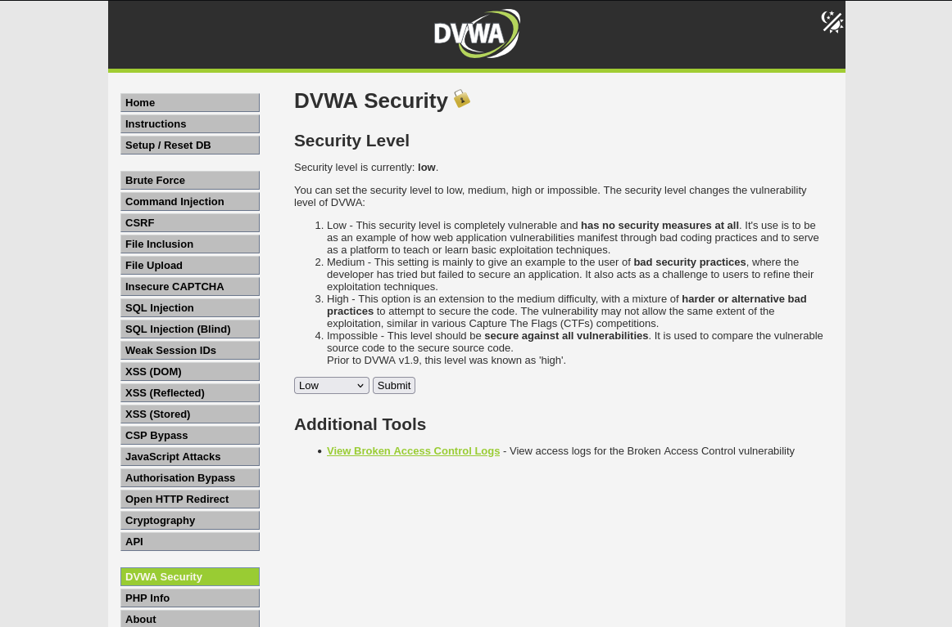

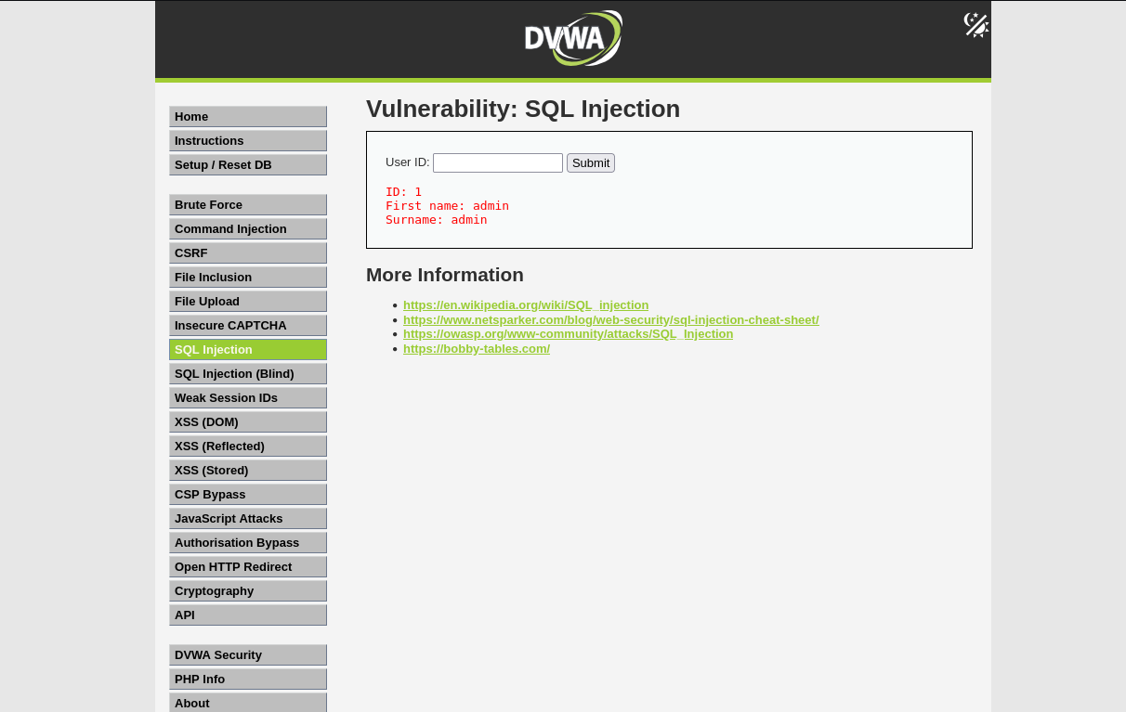

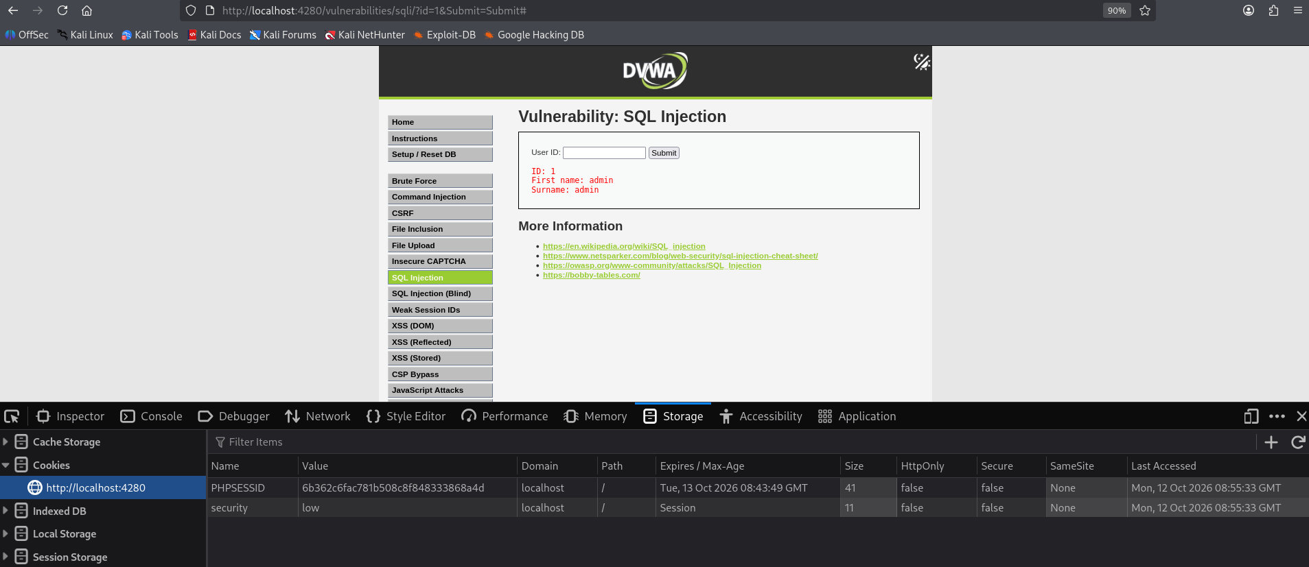

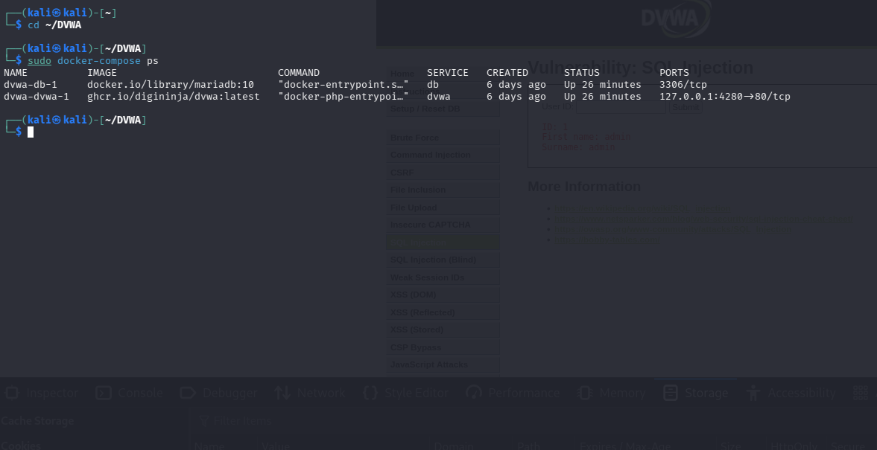
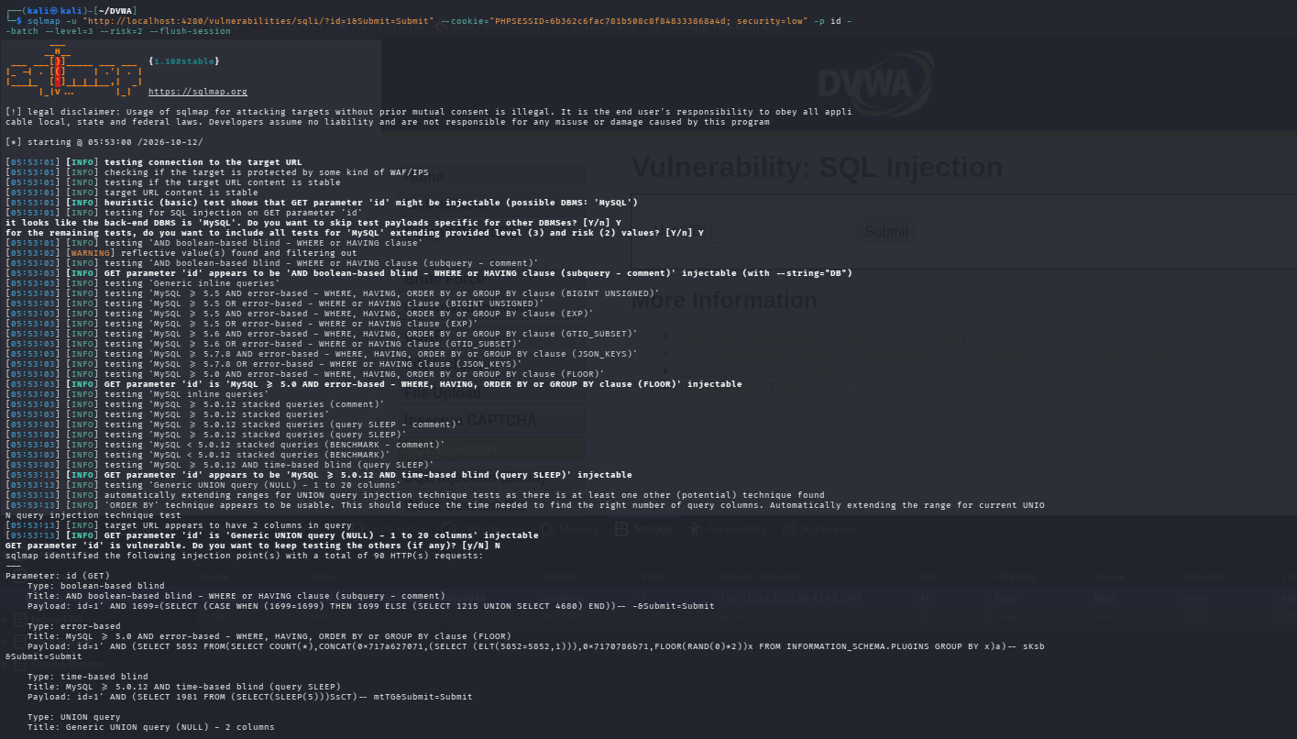

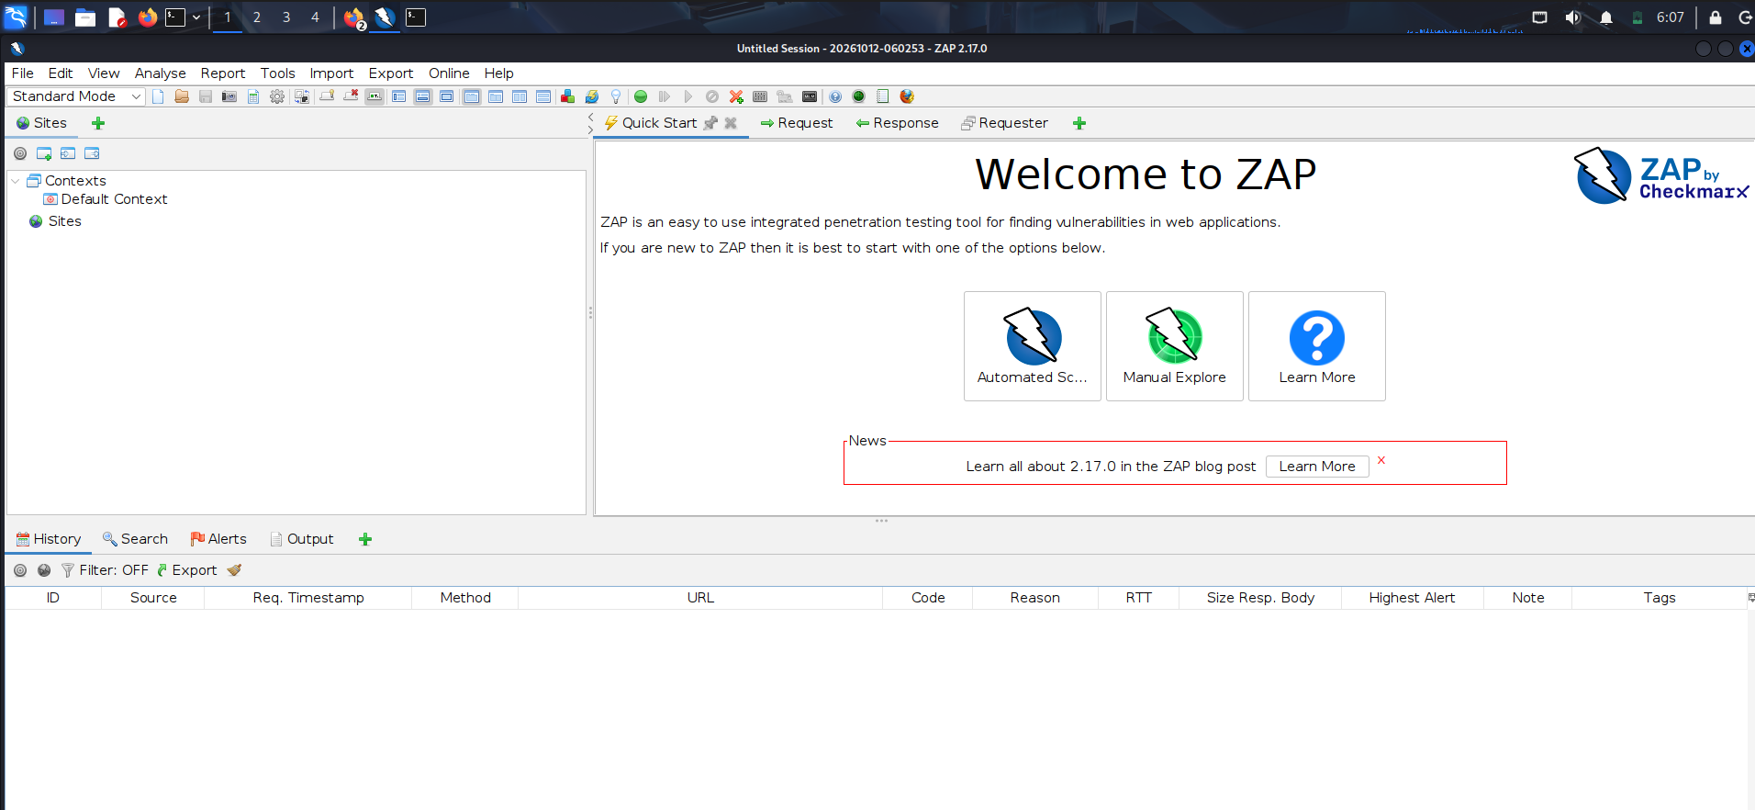

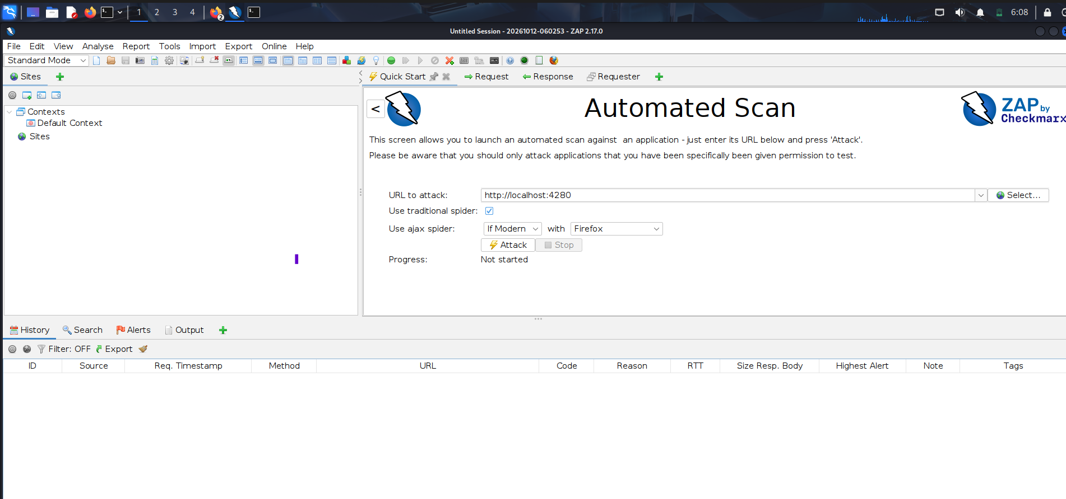

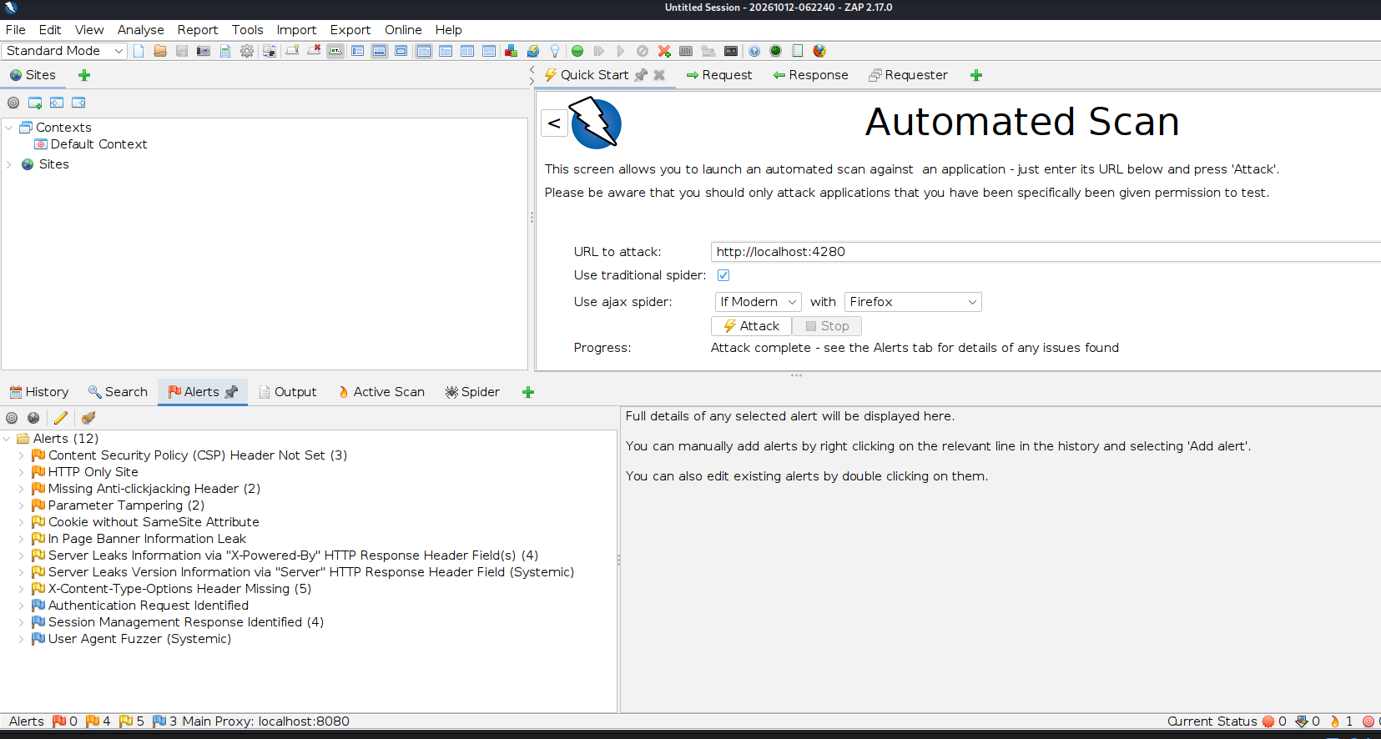

:

Results :
The SQL injection detection experiment was performed using sqlmap and OWASP ZAP on the local DVWA application.
1. sqlmap Results
sqlmap successfully detected SQL injection vulnerabilities in the id parameter of the DVWA SQL Injection page. It identified three injection techniques: error-based SQL injection, time-based blind SQL injection, and UNION-based SQL injection. The backend database was identified as MySQL-compatible (MariaDB fork).
2. OWASP ZAP Results
OWASP ZAP completed the scan with 100% progress and reported 12 alert types. The findings included missing security headers, cookie configuration issues, server information disclosure, parameter tampering, and session management alerts. No explicit SQL injection alert appeared in the reported findings.
3. Comparison
sqlmap directly detected SQL injection vulnerabilities and identified the injection techniques and database type. OWASP ZAP reported a broader range of web application security issues but did not explicitly identify SQL injection in this scan. This difference may be due to the tools' detection methods and the application pages or inputs they tested.
Conclusion
The experiment demonstrated that sqlmap and OWASP ZAP are useful for detecting web application security weaknesses. sqlmap successfully identified SQL injection in the DVWA application, while ZAP reported several other security-related findings. Using multiple tools provides complementary security coverage and helps assess vulnerabilities more effectively.

